Game proposal by: Scott Gajewski
They Came From the Fifth Dimension! -- 2D Beat’em Up RPG
Tagline: They Came From the Fifth Dimension! is a 2D beat ‘em up with role-playing elements where the players control alien blobs who evolve as they attack and devour the human race.
Concept Summary: The game immerses the players in an environment that follows the vein of horror movies like The Blob with gameplay similar to The Simpsons: The Arcade Game, but with one major difference – as players favor certain play strategies, such as eating humans or slithering for a surprise attack, their blob evolve from simple snots to beefy blobs or sneaky slime respectively. Players may also choose to temporarily team up, becoming one creature to unleash terrifying team attacks.
The story is simple enough – the players are globular creatures from another dimension, and Earth is their entrée. Gameplay begins in the back alleyways of Ashtown, where the human race is as of yet unaware of their doom, unlike the stray cats and dogs. The action quickly pours out into town’s main streets, where the residents are now found panicking in fear, and the start of a human resistance builds.
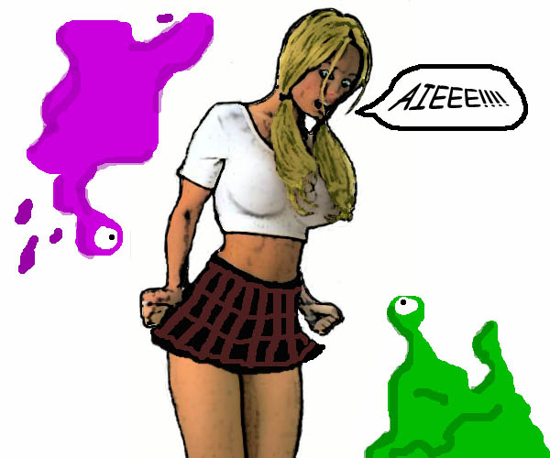
Tentative Controls:
D-pad A button = attack
Up = move blob upstage, climb B button = (hold) slither
Down = move blob downstage, drop X button = eat in direction facing
Left/Right = directional Y button = team up/detach
Justification:
The “classic sci-fi/horror” genre opens a wide assortment of narrative locales and characters not only for the players to encounter, but for the developing artists to borrow from and make their own. The RPG element, which not only adds depth and replay value to the blobs the players control, could also be incorporated into reoccurring antagonists that may attempt to adapt in later conflicts based on the player’s previous strategies, providing programmers with potentially interesting challenges.

